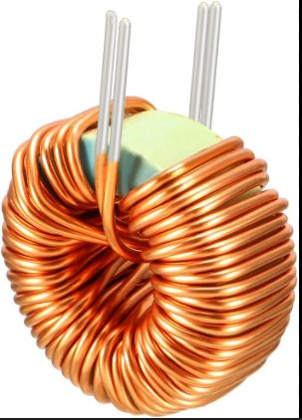
Common Mode Choke (EMI Filter Inductor)
Common Mode Choke ek special inductor hota hai jo SMPS ke input par noise / disturbance ko rokta hai, lekin normal AC current ko aaram se pass hone deta hai.
2️⃣ Short Definition
Common Mode Choke = Noise blocker inductor for AC input line.
3️⃣ Use Case + Connection Syntax
🔹 Kaha lagate hain?
SMPS ke AC input section me – Live aur Neutral dono line me

Inductor kya hota hai?
Inductor ek wire ka coil hota hai jo current ke change ko oppose karta hai aur energy ko magnetic field me store karta hai.
2️⃣ Short Definition
Inductor = current ko smooth rakhne wala magnetic energy store karne wala component.
👉 One Line yaad rakho:
Inductor current ko stable banane wala coil hota hai jo magnetic field me energy store karta hai.

Query
Capacitor aur Inductor dono smooth karte hain, lekin tareeka alag hota hai.
1️⃣ Concept – Farq kya hai?
- Capacitor → Voltage ko smooth karta hai
- Inductor → Current ko smooth karta hai

Use Case + Example

🔹 Capacitor

Voltage ripple ko kam karta hai.
🔹 Inductor

Current ko achanak badhne se rokta hai.

Real World Relation
Example | Capacitor | Inductor
Water Tank | Extra paani store karta hai | Pipe me spring jaisa flow control
SMPS | Output voltage clean karta hai | Current ripple ko smooth karta hai

👉 One Line yaad rakho:
Capacitor voltage ko smooth karta hai, Inductor current ko. Dono milkar perfect DC banate hain.

